Kamran Gul | CMS: 023-25-0161 | CS AI (C) | Lab # 10

Task 1:
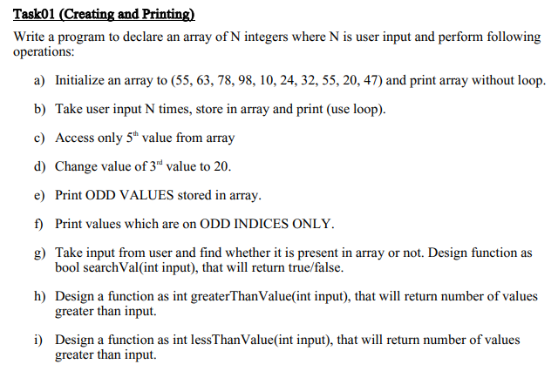
Solution:
#include<iostream>
using namespace std;

bool searchVal(int input);
int greaterThanValue(int inp);
int lessThanValue(int inp);

int main(){
//Task A

int array[] = {55, 63, 78, 98, 10, 24, 32, 55, 20, 47};
cout<<array[0]<<endl;
cout<<array[1]<<endl;
cout<<array[2]<<endl;
cout<<array[3]<<endl;
cout<<array[4]<<endl;
cout<<array[5]<<endl;
cout<<array[6]<<endl;
cout<<array[7]<<endl;
cout<<array[8]<<endl;
cout<<array[9]<<endl;

// Task B

int num;
cout<<"Enter number N: ";
cin>>num;
int b[num];
for (int i =0; i<num;i++){
int user_value;
cout<<"Enter value "<<i+1<<" ";
cin>>user_value;
b[i] = user_value;
}
for (int i =0; i<num;i++){
cout<<b[i]<<" ";
}

// Task C

cout<<endl<<array[4]<<endl;;

// Task D

array[3] = 20;

//Task E

cout<<"Odd Elements in Array"<<endl;
for (int i=0;i<sizeof(array)/sizeof(array[0]);i++){
if(array[i]%2!=0){
cout<<array[i]<<" ";
}}
cout<<endl;

//Task F
cout<<"Elements on Odd indices in Array"<<endl;

for( int i = 1; i<sizeof(array)/sizeof(array[0]); i+=2){
cout<<array[i]<<" ";
}

// Task G
int n;
cout<<" \n Enter number to search: ";
cin>>n;
int x = searchVal(n);
if(x){
cout<<"Value Found"<<endl;
}
else
cout<<"Value not found"<<endl;

//Task H

int c;
cout<<" \n Enter number: ";
cin>>c;
int y = greaterThanValue(c);
cout<<"There are "<< y << " greater numbers then input"<<endl;

// Task I

cout<<" \n Enter number: ";
cin>>c;
int z = lessThanValue(c);
cout<<"There are "<< z << " less numbers then input";

cout<<endl;
system("PAUSE");
return 0;
}

bool searchVal(int input){
int array[] = {55, 63, 78, 98, 10, 24, 32, 55, 20, 47};
for(int i=0; i<sizeof(array)/sizeof(array[0]);i++){
if(array[i]==input) {
return true;
}
else
return false;
}
}

int greaterThanValue(int inp){
int count=0;
int array[] = {55, 63, 78, 98, 10, 24, 32, 55, 20, 47};
for(int i=0; i<sizeof(array)/sizeof(array[0]);i++){
if(array[i]>inp) {
count++;
}
}
return count;
}

int lessThanValue(int inp){
int count=0;
int array[] = {55, 63, 78, 98, 10, 24, 32, 55, 20, 47};
for(int i=0; i<sizeof(array)/sizeof(array[0]);i++){
if(array[i]<inp) {
count++;
}
}
return count;
}
Output:
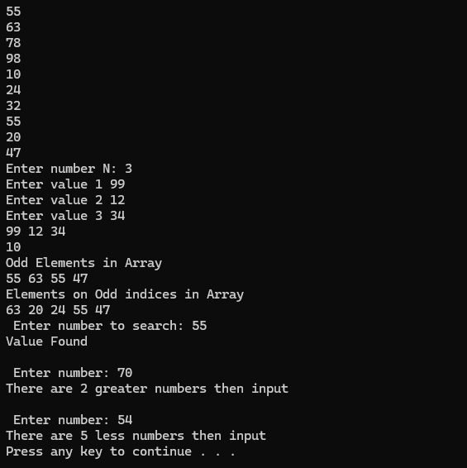

Task 2:
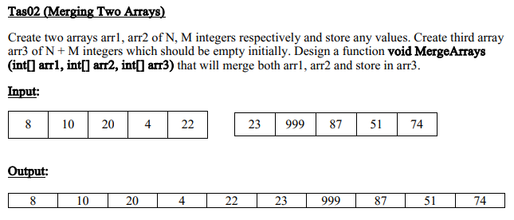
Solution:
#include<iostream>
using namespace std;
void merge(int a[],int b[]){

int merge_array[]={};

for (int i = 0; i<5; i++){
merge_array[i] = a[i];
}
for (int j = 0; j<5; j++){
merge_array[j+5] = b[j];
}
for (int k = 0; k<10; k++){
cout<<merge_array[k]<< " ";
}
}

int main(){
int array1[] = {1,2,3,4,5};
int array2[]={6,7,8,9,10};
cout<<"Merge Array => "<<endl<<endl;
merge(array1,array2);

cout<<endl;
system("PAUSE");
return 0;
}
Output:
